  ______ FORENSICS ______ | Cause, Origin, and Assessment report  cAUSE OF lOSS: [LOSS]  dATE OF LOSS: [LOSS]  DATE OF INSPECTION: [INSPECTION DATE]  Prepared For:  [Client Name]  [Address Line 1]  [Address Line 2]  PREPARED BY:  SYNERGYN  https://www.synergyn-us.com  (786) 843-0243

This assessment was prepared by Synergyn and summarizes the site visit at the time and address listed on the previous page. Documentation of the interview, site observations, field measurements, and determination of “opinions and recommendations” of the damage are detailed below. This assessment was prepared for the client as stated on the previous page and is not intended for any other purpose. Synergyn accepts no responsibility or liability for any use that is made of this document other than by the “Client” for the purposes for which it was originally commissioned and prepared. As discovery is ongoing, conclusions and opinions expressed in this report may be amended or supplemented.

Executive Summary
On [MONTH DAY^{th}, YEAR], Synergyn inspected the residence located at [ADDRESS]. The purpose of this inspection was to investigate reported damage on the property. Also, to identify its nature, duration and cause based on [STORM EVENT] on [D.O.L]. The information contained in this report is a depiction of our examination, available eyewitnesses, past accounts, and documented on-site damages.

Background
The property we inspected is a [BUILDING DETAIL, EX. single-family home with a mono slab foundation and CMU exterior walls]. The main roof is covered with [ROOF COVER TYPE].

The home has been owned by the insured, prior to the date of loss (DOL)s.

After the [STORM EVENT] in [MONTH, YEAR] the homeowners began to notice water staining and leaking in the master bathroom. Since then, the homeowner has attempted temporary roof repairs to prevent further damage and hired made repairs to the master bathroom.
[Client Name] Property
- [ADDRESS]
- Front Facing:
- Roof Style:
- Year Built:
- Beds/Baths:
- Floors:
- Living area:
- Lot area:

Historical Imagery & Timeline
The following historical images were reviewed and obtained from the [IMAGERY SOURCE(S)]. The images show the property pre- and post-date of loss. Wind damages, in most cases, are difficult and near impossible to see from aerial views. To make a full determination of causation and extent of damage by wind on a roof system, it is necessary to view on-site. These aerials can typically provide insight on wind damages to nearby vegetation, new/replaced buildings, roof repairs, roof tarping, etc.

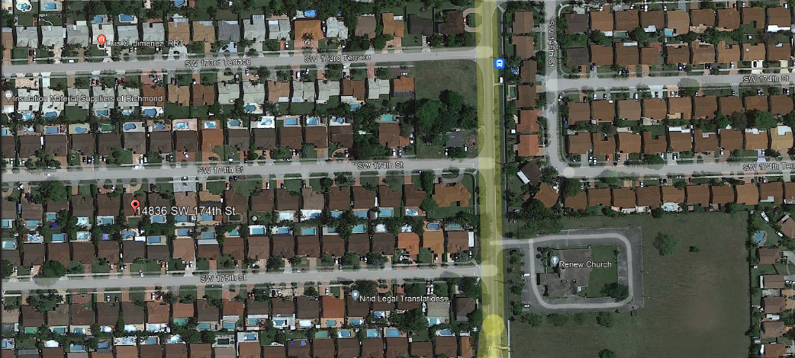
[Pre-DOL date]

- Pre – Date of Loss

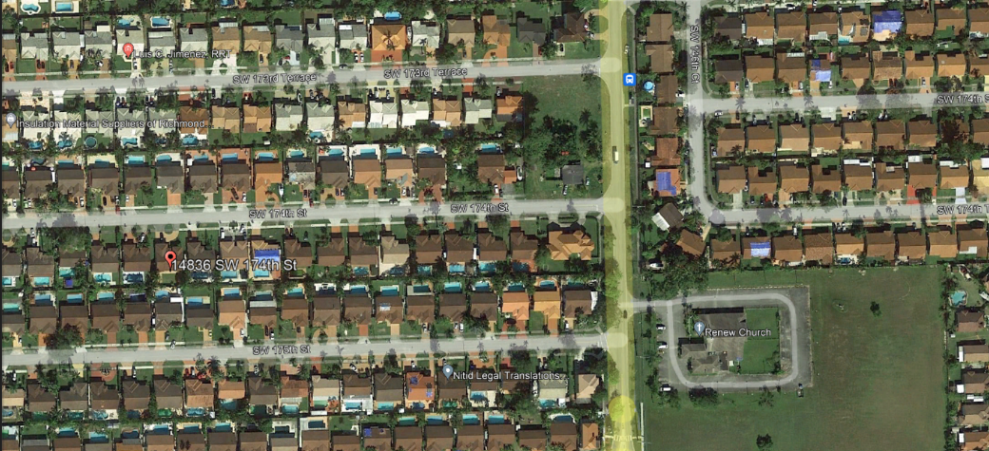
[Earliest Post-DOL date]

- Neighboring tarped roofs
- Missing trees

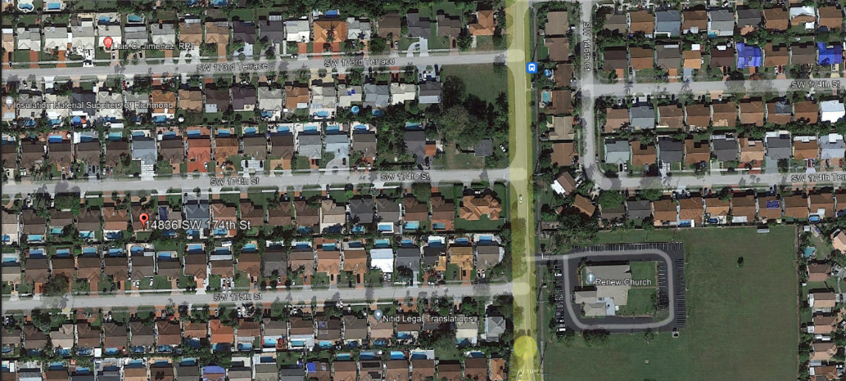
[Post-DOL date]

- Latest Imagery
- Neighboring tarped roofs
- Neighboring repairs
- Neighboring reroofs
- Repairs done at residence

Close-up Historical Imagery & Timeline
Date: XX/XX/XXXX  Obtained From: [Image Source] | Date: XX/XX/XXXX  Obtained From: [Image Source]
- Pre-Date of Loss |  | - Pre-Date of Loss
Date: XX/XX/XXXX  Obtained From: [Image Source] | Date: XX/XX/XXXX  Obtained From: [Image Source]
- Pre-Date of Loss |  | - Pre-Date of Loss
Date: XX/XX/XXXX  Obtained From: [Image Source] |  | Date: XX/XX/XXXX  Obtained From: [Image Source]
- Pre-Date of Loss |  | - Pre-Date of Loss

Permit History
The permit history of the residence above was reviewed and full listing is available in Appendix B located at the end of this report. The report was run with buildfax to find any pertinent information on the home from when the home was built to the time of inspection. The following overview was noted:
[Insert relevant permits to the case in question EX. Hurricane roof damage case – do not include info about plumbing]
[Unless plumbing was somehow damaged in relation to the hurricane event, based on context of correspondence and engineer notes]
- Permit number: XXXXXXXXXXXXXXXX - 09/02/1991
  - Permit Type:
    - Permit Description:
- Permit number: XXXXXXXXXXXXXXXX - 09/02/1991
  - Permit Type:
    - Permit Description:
- Permit number: XXXXXXXXXXXXXXXX - 09/02/1991
  - Permit Type:
    - Permit Description:

On-Site Observations
Photos of the damages described below are provided in Appendix A located at the end of this report. The following observations were made while conducting the investigation
Roof – Synergyn pictures/ and site review after date of loss
- Torn shingles
- Shingles damaged/uplifted in series
- Temporary repairs
- Membrane damage
- Water staining/damage to sheathing

Interior - Synergyn pictures/ and site review after date of loss
- Water staining to ceiling
- Water staining to wall

Exterior – Synergyn pictures/ and site review after date of loss
- Re-attached gutter
- Water damage to facia board
- Water damage to soffit

File Review
The below documents were provided to Synergyn and were reviewed and observed as follows. Photographs from the files are also referenced in Appendix A.
File/Document Description – File/Document Source
- Dated: [DATE]
- Photos Taken: [DATE]

TECHNICAL BACKGROUNDS

High wind SHINGLE

Technical Background

Wind Effects on Shingle Roof Systems
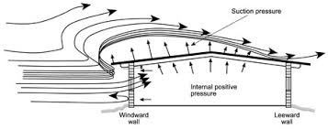
Wind passing over and around a structure with a low-slope roof exerts positive pressure on the windward wall, negative pressure (suction) on the leeward wall and the walls parallel to the flow direction, and suction over most of the roof area. The suction generated at any roof location depends on the wind speed, wind direction, turbulence intensity or gusts, building topography, building geometry and architectural features, and varies with time. Residential roofs are likely to experience high local suction pressures along the roof ridge, roof perimeter and corners as seen in figure 1.
Figure 1 - Wind Effects on Roof
- Windward direction on and around the D.O.L.
09/09/2017 | 09/10/2017 (D.O.L.) | 09/11/2017
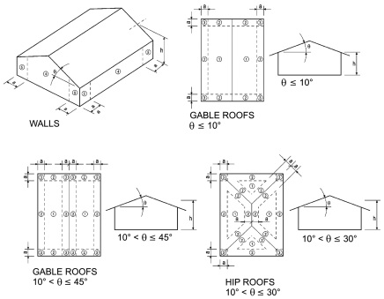
Figure 2 - Component & Cladding Pressure Zones
Wind flowing over a roof creates lift. These lifting forces are not uniform. The lifting forces are always greatest at the windward edges, corners, eaves and rakes, see figure 2. Wind force is defined as strength of the wind in terms of pressure, positive and negative, in and around a building. So, as wind speed increases, so does the wind force. In many cases, the pulling forces of wind are more critical than the push as evident by the loss of roof coverings in many heavy winds and/or rain events. These pulling forces are often referred as wind uplift. As wind crosses over the ridge of a roof, or the perimeter of a roof, the wind tries to maintain its prior speed and direction, yet the wind abruptly pulls away from the building. This creates a vacuum or suction effect on the roof coverings, see figure 1. This constant “suction” will cause the shingles and roofing membranes to uplift. The shingles begin to un-adhere from underlayment. Un-adhering occurs when wind gets up under the shingles thus, causing the holes around the nails to open wider, creating a clear path to the underlayment and damage/broken shingles.
- Hip roof – wind damaged edges, corners, ridges (Witnessed Examples, See Appendix A for more damages)
Edges  Creased shingle | Corners  Un-adhered shingles | Ridge  Missing/repaired shingles
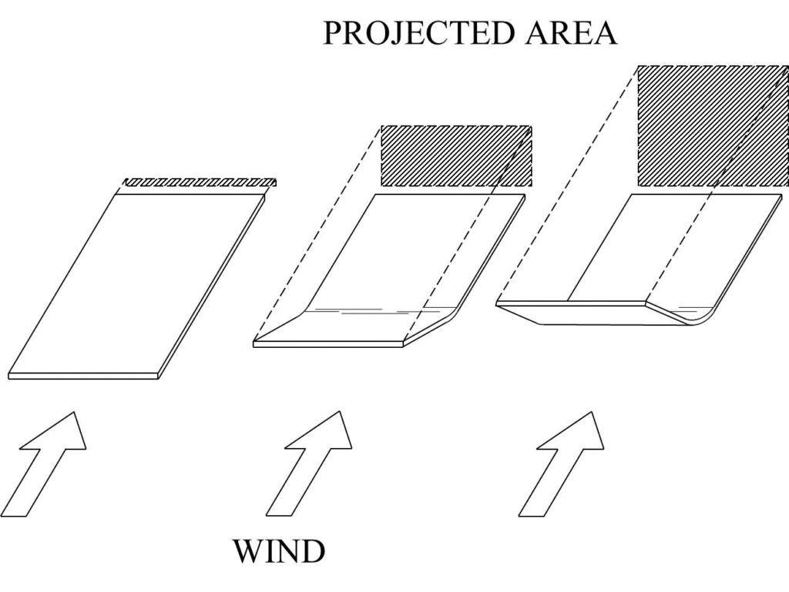
The underlayment of the asphalt shingle roof system is the last line of defense for water intrusion into the residence. Wind-induced suction repeatedly lifts the membrane between the attachments and causes membrane elongation and billowing. The magnitude of the wind-induced suction and the membrane's elastic properties determine the extent of billowing. As wind uplift forces pull on the roofing system, the forces exerted on the shingles are transferred to the fasteners and adhesive on the underlayment and other overlapping portions of the shingle sheets through adhesive. Once these forces exceeded the tensile strength of the adhesive the shingles become un-adhered and rely on weight and fasteners to stay in place.
Figure 3 – Wind Effects on Shingles-Relative increase in projected area (hatched box) as shingle is lifted by the wind. As a shingle tab rises in the wind, more surface area is exposed and, thus, a stronger force occurs.

When considering if wind-related damage to asphalt composition shingles can be hidden or not visually apparent, one must consider how damage to a shingle occurs. First, a wind-induced pressure differential between the front and back of a shingle (i.e., uplift force) has to occur, such that the factory-applied adhesive fails. As the shingle rises in the wind, more surface area is exposed to the wind and, thus, a greater uplift force occurs. Refer to Figure 3. This progression will tend to flip and crease or tear the shingle. The wind forces cause the shingle to flutter and bend such that further creases may develop. Eventually, if the wind force is strong enough, the tabs or shingle sections break off and are carried downwind. This is particularly the case in areas of the roof that are exposed to higher wind forces (e.g., eaves, hips, ridges, etc.). Failure typically occurs at the top of the exposed section, just below the butt end of the overlying shingle.
- Wind damages membrane, Torn, creased, un-adhered (Witnessed Examples, See Appendix A for more damages)
Torn | Creased | Un-adhered

Metal roof

Technical Background

Wind Effects on Metal Roof Systems

Wind passing over and around a structure with a low-slope roof exerts positive pressure on the windward wall, negative pressure (suction) on the leeward wall and the walls parallel to the flow direction, and suction over most of the roof area. The suction generated at any roof location depends on the wind speed, wind direction, turbulence intensity or gusts, building topography, building geometry and architectural features, and varies with time. Residential roofs are likely to experience high local suction pressures along the roof ridge, roof perimeter and corners as seen in figure 1.
Figure 1 - Wind Effects on Roof
- Windward direction on and around the D.O.L. (according to KRSW airport data)
09/27/2022 | 09/28/2022 (D.O.L.) | 09/29/2022
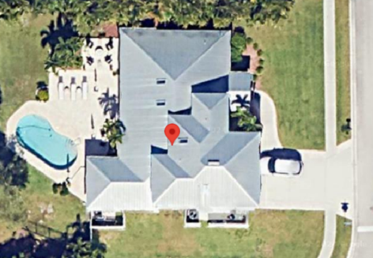 |  | 

Figure 2 - Component & Cladding Pressure Zones
Wind flowing over a roof creates lift. These lifting forces are not uniform. The lifting forces are always greatest at the windward edges, corners, eaves and rakes, see figure 2. Wind force is defined as strength of the wind in terms of pressure, positive and negative, in and around a building. So, as wind speed increases, so does the wind force. In many cases, the pulling forces of wind are more critical than the push as evident by the loss of roof coverings in many heavy winds and/or rain events. These pulling forces are often referred as wind uplift. As wind crosses over the ridge of a roof, or the perimeter of a roof, the wind tries to maintain its prior speed and direction, yet the wind abruptly pulls away from the building. This creates a vacuum or suction effect on the roof coverings, see figure 1. This constant “suction” will cause the metal panels and roofing membranes to uplift. The panels begin to unfasten from underlayment. Un-adhering occurs when wind gets up under the panels thus, causing the holes around the nails to open wider, creating a clear path to the underlayment.

The underlayment of the metal roof system is the last line of defense for water intrusion into the residence. Wind-induced suction repeatedly lifts the membrane between the attachments and causes membrane elongation and billowing. The magnitude of the wind-induced suction and the membrane's elastic properties determine the extent of billowing. As wind uplift forces pull on the roofing system, the forces exerted on the panels are transferred to the fasteners and adhesive on the underlayment and other overlapping portions of the sheets through adhesive. Once these forces exceeded the sheer strength of the fasteners the panels become unfastened and rely on weight and connection joints to stay in place.
Figure 3 – Wind Effects on Shingles-Relative increase in projected area (hatched box) as shingle is lifted by the wind. As a shingle tab rises in the wind, more surface area is exposed and, thus, a stronger force occurs.

When considering if wind-related damage to metal panel can be hidden or not visually apparent, one must consider how damage to a sheet occurs. First, a wind-induced pressure differential between the front and back of a panel (i.e., uplift force) has to occur, such that the factory-applied adhesive or fasteners fails. As the panel rises in the wind, more surface area is exposed to the wind and, thus, a greater uplift force occurs. Refer to Figure 3. This progression will tend to flip and crease the panel. The wind forces cause the panel to flutter and bend such that further creases may develop. Eventually, if the wind force is strong enough, the panel sections break off and are carried downwind. This is particularly the case in areas of the roof that are exposed to higher wind forces (e.g., eaves, hips, ridges, etc.).

High wind TILE

Technical Background

Wind Effects on Roof Systems

Wind passing over and around a structure with a low-slope roof exerts positive pressure on the windward wall, negative pressure (suction) on the leeward wall and the walls parallel to the flow direction, and suction over most of the roof area. The suction generated at any roof location depends on the wind speed, wind direction, turbulence intensity or gusts, building topography, building geometry and architectural features, and varies with time. Residential roofs are likely to experience high local suction pressures along the roof ridge, roof perimeter and corners as seen in figure 2.
Figure 1 - Wind Effects on Roof
- Windward direction on and around the D.O.L.
09/09/2017 | 09/10/2017 (D.O.L.) | 09/11/2017
[Insert Image] | [Insert Image] | [Insert Image]


Wind flowing over a roof creates lift like that on an airplane wing; however, lifting forces are not uniform. The lifting forces are always greatest at the windward edges, corners, eaves, and rakes. Wind force is defined as strength of the wind. So, as wind speed increases, so does the wind force. In many cases, the pulling forces of wind are more critical than the push as evident by the loss of roof coverings in many heavy winds and/or rain events. These pulling forces are often referred as wind uplift. As wind crosses over the ridge of a roof, or the perimeter of a roof, the wind tries to maintain its prior speed and direction, yet the wind abruptly pulls away from the building. This creates a vacuum or suction effect on the roof coverings. This constant “suction” will cause the tile roofing to shift and roofing membranes to uplift. Tile shifting occurs when wind gets up under the tile thus, causing the holes around the nails to open wider. The shifting of the tiles is also created due to the positive and negative pressure of wind where the roof trusses and diaphragm system flex.
Figure 2 - Component & Cladding Pressure Zones
- Hip roof – wind damaged edges, corners, hips (Witnessed Examples, See Appendix A for more damages)
Edges  Stress cracks at mortar | Corners  Repairs | Hips  Uplifted tile and stress cracks at mortar
[Insert Image] | [Insert Image] | [Insert Image]
The underlayment of the tile roof system is the last line of defense for water intrusion into the residence. Wind-induced suction repeatedly lifts the membrane between the attachments and causes membrane elongation and billowing. The magnitude of the wind-induced suction and the membrane’s elastic properties determine the extent of billowing. The fact that water damaged materials exist in the residence indicates the existence of an opening in the membrane and its respective flashings of the underlayment.
As wind uplift forces pull and shift on the roofing system, the forces exerted on the tiles are transferred to the fastening of the roof system (fasteners, adhesive, mortar, etc.). Once the fastening system of the tile is compromised by wind, then damages such as “right corner” cracking of the tiles, slippage of the tiles, ridge/gable eave tiles damage and uplifting, ridge mortar stress cracks, tile uplifting, displaced tiles, missing tiles, etc. Furthermore, once the tile loses the attachment to the roof system, the tile then will resonate on the underlayment causing stress, which causes openings and damage.
- Wind damages membrane, broken, slipped, shifted (Witnessed Examples, See Appendix A for more damages)
Broken | Slipped | Shifted
[Insert Image] | [Insert Image] | [Insert Image]

Water intrusion during and after a weather event can affect a building in two ways:
1. Water causes direct damage to roof membrane, sheathing, fasteners/adhesive/mortar, insulation, and flashing.
2. The amount of water accumulated under the roof membrane will take the path of less resistant and will migrate to other areas of the building causing damage to interior spaces.

High wind FLAT ROOF

Technical Background

Wind Effects on Roof Systems – Flat Roof
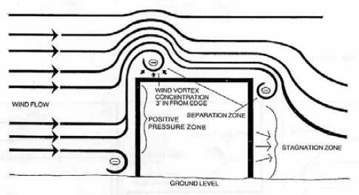
Wind passing over and around a structure with a low slope/flat roof exerts positive pressure on the windward wall, negative pressure (suction) on the leeward wall and the walls parallel to the flow direction, and suction over most of the roof area. The suction generated at any roof location depends on the wind speed, wind direction, turbulence intensity or gusts, building topography, building geometry and architectural features, and varies with time. Commercial roofs are likely to experience high local suction pressures along the roof perimeter and corners as seen in figure 2.
Figure 1 – Wind acting on a flat/Low slope roof
- Windward direction on and around the D.O.L.
11/08/2020 | 11/09/2020 (D.O.L.) | 11/10/2020
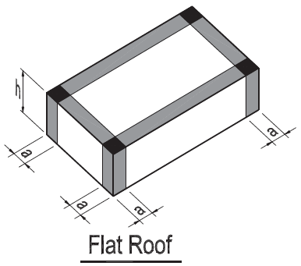
Figure 2 - Component & Cladding Pressure Zones
Wind flowing over a roof creates lift. These lifting forces are not uniform. The lifting forces are always greatest at the windward edges. Wind force is defined as strength of the wind in terms of pressure, positive and negative, in and around a building. So, as wind speed increases, so does the wind force. In many cases, the pulling forces of wind are more critical than the push as evident by the damage of roof coverings in many winds and/or rain events. These pulling forces are often referred as wind uplift. As wind crosses the perimeter of a roof, the wind tries to maintain its prior speed and direction, yet the wind abruptly pulls away from the building. This creates a vacuum or suction effect on the roof coverings, see figure 1. This constant “suction” will cause the roofing membranes to uplift. The membrane begins to un-adhere from roof deck below. Un-adhering occurs when wind gets up under membrane thus, causing billowing, tears, Un-adhering, and other damages, creating a path to the decking and sub structure of the roof.

- Flat/Low slope roof – wind damaged edges, corners (Witnessed Examples, See Appendix A for more damages)
Edges  Water evident at soffit | Corners  Damage and repairs | Field  Damage and repairs
The roof system of components, and can include the following: membrane, flashings, penetrations, drainage, ventilation, insulation, and decking. If one component were to fail, it can adversely affect the entire roofing system. Most roof failures that lead to water/moisture intrusion into the roofing systems come through the water-proofing system which typically consists of the membrane, seals (waterproof joint), and flashing. The magnitude of the wind-induced suction and the membrane's elastic properties determine the extent of billowing and damage put onto the water-proofing components.
As wind uplift forces pull on the roofing system, and the force exceed the tensile strength of the adhesive, the roof loses the ability to create the necessary waterproofing for the system in place. Water intrusion during and after a weather event can affect a building in two ways:
1. Water causes direct damage to roof membrane, substrates, drainage, insulation, and flashing.
2. The amount of water accumulated within the roof system will take the path of less resistant and will migrate to other areas of the building causing damage to interior spaces.

High wind ROOF/FLAT ROOF COMBO [update may be necessary]

Technical Background

Wind Effects on Roof Systems

Wind passing over and around a structure with a low slope/flat roof exerts positive pressure on the windward wall, negative pressure (suction) on the leeward wall and the walls parallel to the flow direction, and suction over most of the roof area. The suction generated at any roof location depends on the wind speed, wind direction, turbulence intensity or gusts, building topography, building geometry and architectural features, and varies with time. Commercial roofs are likely to experience high local suction pressures along the roof perimeter and corners as seen in figure 2.
Figure 1 – Wind acting on a flat/Low slope roof

Figure 2 - Wind Effects on low slope roof

- Windward direction on and around the D.O.L.
11/08/2020 | 11/09/2020 (D.O.L.) | 11/10/2020

Figure 3 - Component & Cladding Pressure Zones

Figure 4 - Component & Cladding Pressure Zones

Wind flowing over a roof creates lift. These lifting forces are not uniform. The lifting forces are always greatest at the windward edges, corners, eaves, and rakes. Wind force is defined as strength of the wind in terms of pressure, positive and negative, in and around a building. So, as wind speed increases, so does the wind force. In many cases, the pulling forces of wind are more critical than the push as evident by the damage of roof coverings in many winds and/or rain events. These pulling forces are often referred as wind uplift. As wind crosses the ridge a roof, the wind tries to maintain its prior speed and direction, yet the wind abruptly pulls away from the building. This creates a vacuum or suction effect on the roof coverings, see figure 1 & 2. This constant “suction” will cause the roofing membranes to uplift. The membrane begins to un-adhere from roof deck below. Un-adhering occurs when wind gets up under membrane thus, causing billowing, tears, Un-adhering, and other damages, creating a path to the decking and sub structure of the roof.

- Low slope roof – wind damaged edges, corners (Witnessed Examples, See Appendix A for more damages)
Edges  Unadhered membrane | Corners  Unadhered membrane | Field  Damage and repairs

The roof system of components can include the following: membrane, flashings, penetrations, drainage, ventilation, insulation, and decking. If one component were to fail, it can adversely affect the entire roofing system. Most roof failures that lead to water/moisture intrusion into the roofing systems come through the water-proofing system which typically consists of the membrane, seals (waterproof joint), and flashing. The magnitude of the wind-induced suction and the membrane's elastic properties determine the extent of billowing and damage put onto the water-proofing components.
As wind uplift forces pull on the roofing system, and the force exceed the tensile strength of the adhesive, the roof loses the ability to create the necessary waterproofing for the system in place. Water intrusion during and after a weather event can affect a building in two ways:
1. Water causes direct damage to roof membrane, substrates, drainage, insulation, and flashing.
2. The amount of water accumulated within the roof system will take the path of less resistant and will migrate to other areas of the building causing damage to interior spaces.

Low wind TILE

Technical Background

Wind Effects on Roof Systems

Wind passing over and around a structure with a low-slope roof exerts positive pressure on the windward wall, negative pressure (suction) on the leeward wall and the walls parallel to the flow direction, and suction over most of the roof area. The suction generated at any roof location depends on the wind speed, wind direction, turbulence intensity or gusts, building topography, building geometry and architectural features, and varies with time. Residential roofs are likely to experience high local suction pressures along the roof ridge, roof perimeter and corners as seen in figure 2.
Figure 1 - Wind Effects on Roof
- Windward direction on and around the D.O.L.
11/08/2020 | 11/09/2020 (D.O.L.) | 11/10/2020
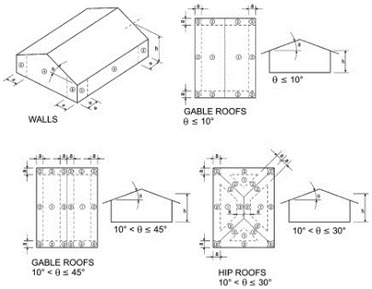
Wind flowing over a roof creates lift like that on an airplane wing; however, lifting forces are not uniform. The lifting forces are always greatest at the windward edges, corners, eaves, and rakes. Wind force is defined as strength of the wind. So, as wind speed increases, so does the wind force. In many cases, the pulling forces of wind are more critical than the push as evident by the loss of roof coverings in many heavy winds and/or rain events. These pulling forces are often referred as wind uplift. As wind crosses over the ridge of a roof, or the perimeter of a roof, the wind tries to maintain its prior speed and direction, yet the wind abruptly pulls away from the building. This creates a vacuum or suction effect on the roof coverings. This constant “suction” will cause the tile roofing to shift and roofing membranes to uplift. Tile shifting occurs when wind gets up under the tile thus, causing the holes around the nails to open wider. The shifting of the tiles is also created due to the positive and negative pressure of wind where the roof trusses and diaphragm system flex.
Figure 2 - Component & Cladding Pressure Zones
The underlayment of the tile roof system is the last line of defense for water intrusion into the residence. Wind-induced suction repeatedly lifts the membrane between the attachments and causes membrane elongation and billowing. The magnitude of the wind-induced suction and the membrane’s elastic properties determine the extent of billowing. The fact that water damaged materials exist in the residence indicates the existence of an opening in the membrane and its respective flashings of the underlayment.
Water intrusion during and after a weather event can affect a building in two ways:
1. Water causes direct damage to roof membrane, sheathing, fasteners/adhesive/mortar, insulation, and flashing.
2. The amount of water accumulated under the roof membrane will take the path of less resistant and will migrate to other areas of the building causing damage to interior spaces.

Low wind SHINGLE

Technical Background

Wind Effects on Roof Systems

Wind passing over and around a structure with a low-slope roof exerts positive pressure on the windward wall, negative pressure (suction) on the leeward wall and the walls parallel to the flow direction, and suction over most of the roof area. The suction generated at any roof location depends on the wind speed, wind direction, turbulence intensity or gusts, building topography, building geometry and architectural features, and varies with time. Residential roofs are likely to experience high local suction pressures along the roof ridge, roof perimeter and corners as seen in figure 1.
Figure 1 - Wind Effects on Roof
- Windward direction on and around the D.O.L.
11/07/2020 | 11/08/2020 (D.O.L.) | 11/09/2020
[Insert Image] | [Insert Image] | [Insert Image]


Wind flowing over a roof creates lift. These lifting forces are not uniform. The lifting forces are always greatest at the windward edges, corners, eaves and rakes, see figure 2. Wind force is defined as strength of the wind in terms of pressure, positive and negative, in and around a building. So, as wind speed increases, so does the wind force. In many cases, the pulling forces of wind are more critical than the push as evident by the loss of roof coverings in many heavy winds and/or rain events. These pulling forces are often referred as wind uplift. As wind crosses over the ridge of a roof, or the perimeter of a roof, the wind tries to maintain its prior speed and direction, yet the wind abruptly pulls away from the building. This creates a vacuum or suction effect on the roof coverings, see figure 1. This constant “suction” will cause the shingles and roofing membranes to uplift. The shingles begin to un-adhere from underlayment. Un-adhering occurs when wind gets up under the shingles thus, causing the holes around the nails to open wider, creating a clear path to the underlayment and damage/broken shingles.
Figure 2 - Component & Cladding Pressure Zones
The underlayment of the asphalt shingle roof system is the last line of defense for water intrusion into the residence. Wind-induced suction repeatedly lifts the membrane between the attachments and causes membrane elongation and billowing. The magnitude of the wind-induced suction and the membrane's elastic properties determine the extent of billowing. As wind uplift forces pull on the roofing system, the forces exerted on the shingles are transferred to the fasteners and adhesive on the underlayment and other overlapping portions of the shingle sheets through adhesive. Once these forces exceeded the tensile strength of the adhesive the shingles become un-adhered and rely on weight and fasteners to stay in place.


When considering if wind-related damage to asphalt composition shingles can be hidden or not visually apparent, one must consider how damage to a shingle occurs. First, a wind-induced pressure differential between the front and back of a shingle (i.e., uplift force) has to occur, such that the factory-applied adhesive fails. As the shingle rises in the wind, more surface area is exposed to the wind and, thus, a greater uplift force occurs. Refer to Figure 3. This progression will tend to flip and crease or tear the shingle. The wind forces cause the shingle to flutter and bend such that further creases may develop. Eventually, if the wind force is strong enough, the tabs or shingle sections break off and are carried downwind. This is particularly the case in areas of the roof that are exposed to higher wind forces (e.g., eaves, hips, ridges, etc.). Failure typically occurs at the top of the exposed section, just below the butt end of the overlying shingle.
Figure 3 – Wind Effects on Shingles-Relative increase in projected area (hatched box) as shingle is lifted by the wind. As a shingle tab rises in the wind, more surface area is exposed and, thus, a stronger force occurs.

- Wind damages membrane, Torn, creased, un-adhered (Witnessed Examples, See Appendix A for more damages)
Torn | Creased | Torn/Missing

Low wind FLAT ROOF

Technical Background

Wind Effects on Roof Systems

Wind passing over and around a structure with a low slope/flat roof exerts positive pressure on the windward wall, negative pressure (suction) on the leeward wall and the walls parallel to the flow direction, and suction over most of the roof area. The suction generated at any roof location depends on the wind speed, wind direction, turbulence intensity or gusts, building topography, building geometry and architectural features, and varies with time. Commercial roofs are likely to experience high local suction pressures along the roof perimeter and corners as seen in figure 2.
Figure 1 – Wind acting on a flat/Low slope roof
- Windward direction on and around the D.O.L.
11/08/2020 | 11/09/2020 (D.O.L.) | 11/10/2020

Figure 2 - Component & Cladding Pressure Zones
Wind flowing over a roof creates lift. These lifting forces are not uniform. The lifting forces are always greatest at the windward edges. Wind force is defined as strength of the wind in terms of pressure, positive and negative, in and around a building. So, as wind speed increases, so does the wind force. In many cases, the pulling forces of wind are more critical than the push as evident by the damage of roof coverings in many winds and/or rain events. These pulling forces are often referred as wind uplift. As wind crosses the perimeter of a roof, the wind tries to maintain its prior speed and direction, yet the wind abruptly pulls away from the building. This creates a vacuum or suction effect on the roof coverings, see figure 1. This constant “suction” will cause the roofing membranes to uplift. The membrane begins to un-adhere from roof deck below. Un-adhering occurs when wind gets up under membrane thus, causing billowing, tears, Un-adhering, and other damages, creating a path to the decking and sub structure of the roof.

- Flat/Low slope roof – wind damaged edges, corners (Witnessed Examples, See Appendix A for more damages)
Edges  Water evident at soffit | Corners  Damage and repairs | Field  Damage and repairs
The roof system of components, and can include the following: membrane, flashings, penetrations, drainage, ventilation, insulation, and decking. If one component were to fail, it can adversely affect the entire roofing system. Most roof failures that lead to water/moisture intrusion into the roofing systems come through the water-proofing system which typically consists of the membrane, seals (waterproof joint), and flashing. The magnitude of the wind-induced suction and the membrane's elastic properties determine the extent of billowing and damage put onto the water-proofing components.
As wind uplift forces pull on the roofing system, and the force exceed the tensile strength of the adhesive, the roof loses the ability to create the necessary waterproofing for the system in place. Water intrusion during and after a weather event can affect a building in two ways:
1. Water causes direct damage to roof membrane, substrates, drainage, insulation, and flashing.
2. The amount of water accumulated within the roof system will take the path of less resistant and will migrate to other areas of the building causing damage to interior spaces.

Wind effect on Walls and Components
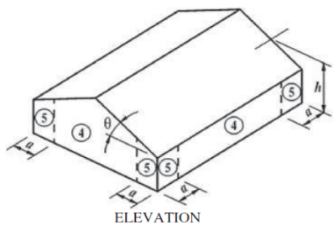
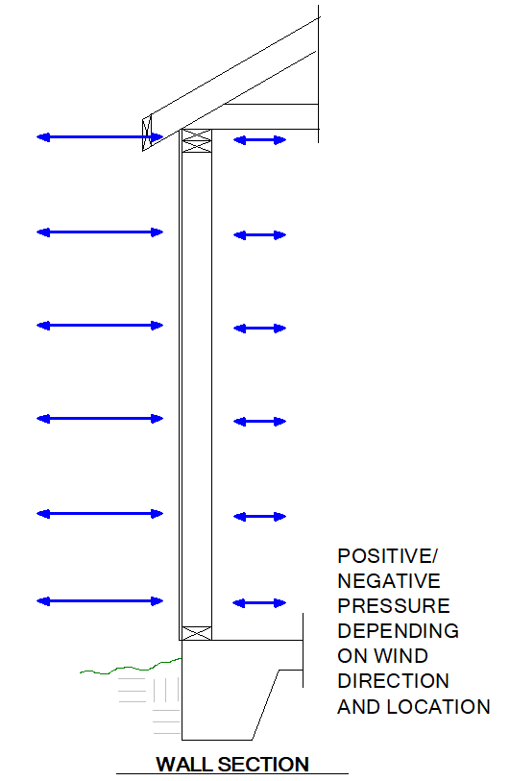
Wind will create positive and negative pressures on the structure depending on the wind direction and the face of the structure. These pressures are not uniform and are dependent on many conditions such as wind speed, wind direction, turbulence intensity or gusts, building topography, building geometry, and architectural features, and varies with time. The windward side of the structure is exposed to the positive external pressure as a force and the sidewall and leeward side of the structure is exposed to the negative external pressure. These characteristics of pressure and force to the structure are the highest at the corners (see the figure to the right). These pressures and forces, positive and negative, are used simultaneously with one another. Wind force is defined as strength of the wind in terms of pressure, positive and negative, in and around a building. So, as wind speed increases, so does the wind force. In many cases, the pulling forces of wind are more critical than the push. As wind changes direction around the structure, the wind tries to maintain its prior speed and direction, yet the wind abruptly pulls away from the building.
Stucco Cladded Walls
Walls, windward or leeward, are designed to resist the positive and negative forces. The design consists of the mechanics and assembly of materials, ie, connection to foundation, connection to truss, lateral (in-plane and out of plane) loading, gravity loading (weight of materials, etc), etc. Under these considerations there are multiple failure modes and design conditions to consider, such as bending, shear, deflection, and overturning. When it comes to components and cladding system the wind pressure is dependent on the tributary or effective area of said component. Depending on the building materials and assembly can create openings when effected by winds.
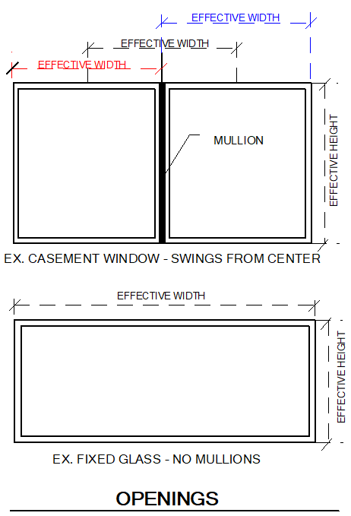
Stucco Cladded walls are considered a brittle finish and are held by design with a higher deflection limit. This is due to the inability of its elastic behavior. Thus, with lateral loads and deflection the material will stress, crack, separate the material. This creates the ability for water intrusion within the building envelope and can cause damage to building components.
Windows, Doors, Openings
Windows, doors, and openings have many types of uses within a buildings design. When designing an opening such as windows and doors, there are many design considerations to account for, such as the load path from gravity loads and the in-plane and out of plane lateral loads. For out of plane loading on window and door components, that opening is considered by its effective area in order for the component to transfer the loading to the surrounding structure. These areas or load transfer are typically defined by the manufacturer of a window or door.
Typical damage to a window can be on the components themselves, ie mullions, glass, frame as well to the connection from the window to the structure due to the distribution of the out of plane loading ie, connection of frame, separation of frame to structure, separation and damage to cladding elements around the opening which can lead to water intrusion and damage further building materials.
- Cladding – Windows, doors, walls (See Appendix A for damages)
Window  Separation | Wall  Separation, stucco damage | Door  Separation, stucco damage

Water Travel
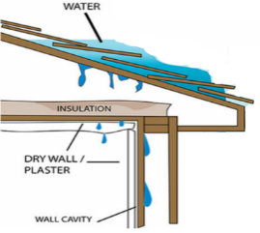
Moisture travel that is inside a wall cavity or on the ceiling material from a failed roofing system will become visible only after the surrounding building material has exhausted its ability to continue to absorb water. As a result, homeowners usually are not aware of the extent of damage until bulging, peeling and discoloration of the gypsum board and other material finishes is observed inside the property.
Figure 3 - Water Travel
- Water travel correlation witnessed (Witnessed Example, See Appendix A for more damages)
Roof  [Image description] | Attic  [Image description] | Interior  Gypsum water staining
[Insert Image] | [Insert Image] | [Insert Image]

Wood Damage
Wood elements have been adversely affected by the water and moisture introduced by the roof leak. Wood is hydroscopic. The durability of wood is often a function of water since wood is a hygroscopic material, which means it can naturally take on and give off water to balance out with its surrounding environment. The fibers of wood run longitudinally and are shaped like drinking straws. As water penetrates, these wood fibers absorb water. First, the water is held in the cell walls (bound water), then any additional water would fill the cell cavities (free water) of the tubular cells. Free water is relatively accessible for fungi to start growing. Therefore, biodegradation generally only gets started if the moisture content of the wood is above fiber saturation.
- Moisture content (MC) is a measure of how much moisture is contained in a piece of wood relative to the dry weight of the wood. Wood placed in an environment with stable temperature and relative humidity will eventually reach its
- Equilibrium Moisture Content (EMC). Wood used indoors should typically stabilize between 8% and14% moisture content; outdoors at 12% to18%. However, the moisture must remain at or below 19% (below fiber saturation which is reached at 28% MC) to avoid the degradation, and subsequent failure of wooden structural members.
- Fiber Saturation is reached when the cells and the cell walls are holding as much moisture as they can. Once the cells and cell walls are filled, additional moisture absorbed by the wood fills up the cavities between the cells. Water held in the cells and cell walls is called bound water and is not available for fungi growth. Water in the cavities between the cells is called free water, and this moisture is available for fungal growth. Decay fungi can generally only progress when the moisture content of wood is above fiber saturation. The fiber saturation point is also the limit for wood shrinkage. Wood shrinks or swells as its moisture content changes, but only when water is taken up or given off from the cells or cell walls. Moisture contact can produce warpage as well, because wood tends to shrink at different rates in different directions.

Gypsum Board Damage
Gypsum board (also known as drywall, sheetrock, or plaster board) was used to cover the interior walls of this property, consisting of compacted gypsum between two sheets of paper. Gypsum board will weaken and become permanently damaged when it encounters water for an unknown period.
The water staining observed are characteristic of water damaged drywall.. Within 24 to 48 hours, water and moisture can have an adverse effect on drywall (gypsum wallboard), it can cause gypsum and plaster board to lose its structural properties and decompose when not treated or removed in a timely and proper fashion.
It is Synergyn’s opinion and an industry standard that when water or moisture has caused gypsum or plaster to lose its self-restraint, it shall be replaced. When mold (fungi) is buried within materials and inaccessible to chlorine or disinfectants, the mold infested materials should be replaced. According to the Gypsum Association recommendation on assessing water damage gypsum board:
“Remove and replace all water damaged drywall and insulation within 24 hours. If the drywall is not removed within 24 hours, if previous water damage has caused microbial growth, or the sheetrock has been damaged by unsanitary or contaminated water, then extensive controls will be necessary for the removal.”

Tile Flooring
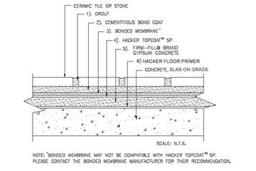
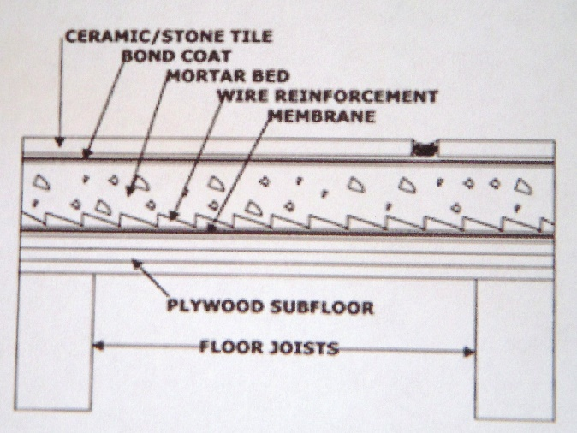
Tile flooring is typically connected to the substructure below with cement mortar or epoxy like adhesives. Proper installation varies with different manufactures and material of tile and substructure below. The quality and cost of ceramic and stone tile installations are influenced by the stability, permanence, and precision of installation of the backing or base material. The age, workability, and quality of the thin-set mortar all affect the strength of the bond developed in the ceramic tile floor installation. Tiles that are loose, sound hollow or crunchy, or have lifted can be referred to as de-bonded or delaminated. There are many factors that can cause delamination of tile floors. The root cause of most floor tile problems involves installation deficiencies. In order to gain adequate coverage and contact between the mortar, the subfloor, and the backs of the tiles, the installer must provide an adequate thickness of workable mortar and must either work the tile into place and/or beat the tile with a mallet to ensure firm contact. For large ceramic tile installations, movement joints should be placed at regular intervals and at stress concentration points, such as that which occurs through doorways, to allow the tile to expand and contract with changing temperature.
Tile Council of North America (TCNA), Handbook for Ceramic, Glass, and Stone Tile Installation:
- Mortar Coverage for Ceramic Tile: “Average contact area for dry areas is 80% and for wet areas is 95%. Mortar coverage is to be evenly distributed to support edges and corners.

- Directional Troweling: “To ensure proper coverage of the bonding surface of 8” x 8” and larger tiles and to provide full support of edges and corners, select a notched trowel sized to facilitate the proper coverage. Key the mortar into the substrate with the flat side of the trowel. Comb with the notched side of the trowel in one direction. Firmly press tiles into the mortar and move them perpendicularly across the ridges forward and back to flatten the ridges and fill the valley. This method can produce maximum coverage, with the corners and edges fully supported, without back-buttering or beat-in.”

- Movement Joint: “Movement Joints – Mandatory according to EJ171. When Glass tile is used, adhere to more frequent placement recommendations within the ranges listed in EJ171.”

  - EJ171: “Interior – 20’ to 25’ in each direction”, “Exterior 8’ to 12’ in each direction.”

American National Standard Specifications for the installation of Ceramic Tile (ANSI A108, A118, and A136), Material and Installation standards:
- 3.3.2- “Average uniform contact area shall be not less than 80% except on exterior or shower installations where contact area shall be 95% when no less than three tiles or tile assemblies are removed for inspection. The 80% or 95% coverage shall be sufficiently distributed to give full support to the tile with particular attention to this support under all corners of the tile.”
Tile flooring damages can appear as several different types including but not limited to:
- Tenting
- Buckling
- De-lamination
- Mold/Mildew
- cracking
- Staining
Resources

The data resources reviewed in relationship to the opinions included in this report were obtained from the following reference materials:

- Handbook for Ceramic, Glass, and Stone Tile Installation – Tile Council of North America, Inc.
- American National Standard Specifications for the installation of Ceramic Tile (ANSI A108, A118, and A136), Material and Installation standards – Tile Council of North America, Inc.

Parapet/Stepped Roof
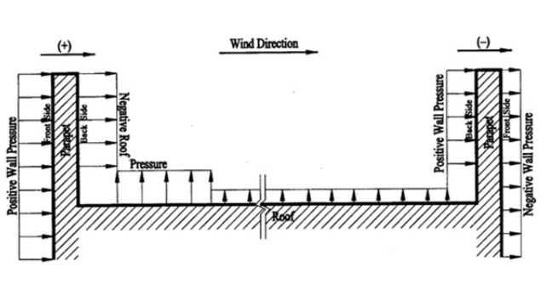
Figure 3 – Wind Pressure on Parapet Walls/Stepped Roofs
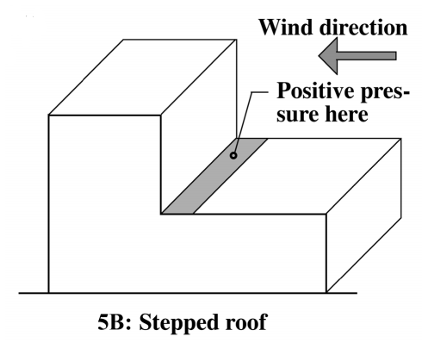

Parapets and stepped roofs can provide Aesthetics to the building but is also used to distribute wind pressures and fire separations. Wind creates large pressure differences at the perimeters and stepped portions of a structure, using a parapet or stepped roof in wind design can extrude these forces a distance away from the perimeter or separation. Given the functionality of a parapet or stepped roof for wind design, this also has an adverse effect typically seen for water proofing failure due to wind. The additional requirements that are a part of the parapet or stepped roof water-proofing such as the need for vertical membranes, flashing, and exterior cladding creates an increase in the members that are typically found damaged to wind design and allow water intrusion into the roofing system. Furthermore, the additional oscillating pressures, vertical and horizontal, at these locations act on the structure and cladding material. At these intersections is typical to find wind, water, moisture, etc damage.

Resources
The data resources reviewed in relationship to the opinions included in this report were obtained from the following reference materials:

- Combination of Wind Load and Rain Load on Flat (Low-Slope) Roofs, by Stephan Patterson and Madan Mehta
https://iibec.org/wp-content/uploads/2012-bes-patterson-mehta.pdf

Hailstone Impact to Roofing System
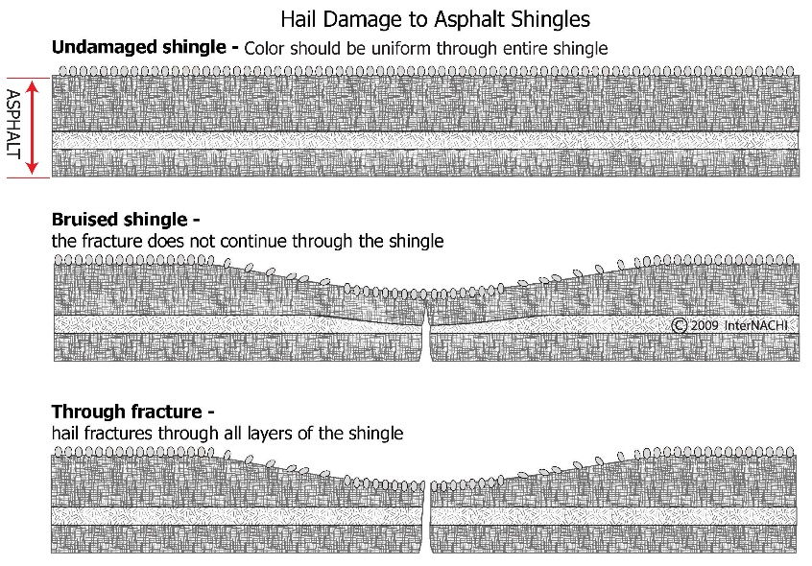
The roofing material for a building is typically designed not only for aesthetics reasons but also for the conditions the roof will be exposed to and the functionality of its purpose. Some roofs are sloped more or use a material to aid in shedding the snow. Some roofing cladding is added to the roof to aid in the “weight” on a structure to offset conditions of wind. Whichever the type and material that is chosen each factor should be considered and properly attached to function as a system.
A typical wooden truss roof system has multiple layers for the system to function as intended and designed. This typically consists of the wood truss or rafters, sheathing or roof decking, underlayment, and then the exposed roof cladding on the top. Each one of these layers can have multiple ways of attachment, size, material type, etc depending on the design, but each part is necessary for the roofing system to provide its designed intent and functionality. Once one of these systems is compromised, the system and design intent can fail.
Hailstone impact to roof coverings can result in cosmetic blemishes and/or functional damage. Hailstone impact can mimic a sharp pressure on the roofing material during impact. The impact can differ based on many factors, velocity of the object, size of object, shape of object, mass of the object, angle/trajectory of the object, angle of the surface, material of the surface, etc. Cosmetic blemishes include the displacement of algae, small dents in metal vents, or where only a few granules are dislodged from random areas of the roof. Functional damage exists when the impact to the shingle or tile has punctured, torn, indented, cracked, or break the material sufficiently to result in a leak or reduce the expected life of the shingle or tile. Hailstorms with hail of sufficient size, hardness, and speed to cause functional damage to asphalt composition shingles will also leave widespread torn or chipped shingle edges, dents in metal roof accessories, and tears or holes in screens. It is generally accepted in the roofing industry that hard hailstones of at least 1-inch diameter are required to damage three-tab style fiberglass-mat asphalt composition shingles in good condition.
Roofing Cladding: Types and representative damage from Hailstone impacts
- Tile: Typically manufactured with concrete and clay material, roofing tile come in multiple sizes, shapes, colors, and attachment methods. While tile roofs tend to be considered to have one of the longest roofing materials lifespans, the material is typically considered as the brittle type. Impact damage consists of a break, cracking, and with “sharp” edges
- Shingle: Typically manufactured with an asphalt or composite asphalt and fiberglass material, shingles come in multiple shapes, colors, aesthetics and are typically mechanically attached. Impact damage to shingle roof consist of bends, punctures, “pitting”, and granule loss which can affect the roofing system when damaged.
- Metal: Manufactured with a composite of metal material, this system can come in many sizes, colors, and shapes. A metal roof is typically installed with large sheets and mechanically attached to the roof. Impact damage to a metal roof consist of bends, dents, punctures, and possible breaks which can affect the roofing system when damaged.
Resources
The data resources reviewed in relationship to the opinions included in this report were obtained from the following reference materials:

- InterNACHI - https://www.nachi.org/
- InterNACHI Gallery Hail Damage to Asphalt Shingles - Hail Damage to Asphalt Shingles - Inspection Gallery - InterNACHI®

Laminate Flooring
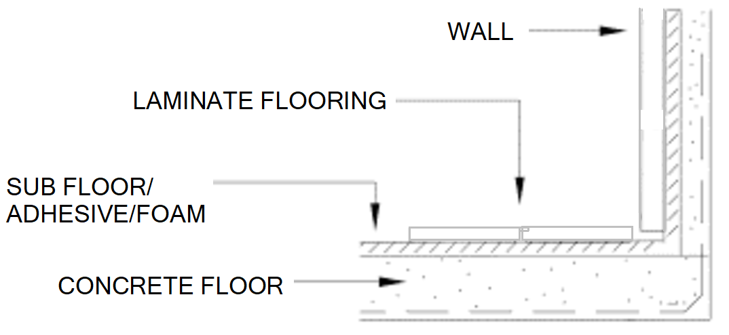
Laminate flooring is either connected to the substructure below with adhesive or directly laid over a barrier and foam pad (floating floor). Proper installation varies with different manufactures and material of tile and substructure below. When water/moisture comes between the flooring and the substructure the chance of the damage of materials is at high risk. Water/moisture intrusion between the materials can happen in many ways i.e. Flooded floor system, water mitigation under the flooring system, etc. Damage may not become evident for several weeks or months after the incident. Laminate flooring damages consistent with water/moisture issues comes in forms of:
- Buckling/Warping
- De-lamination
- Mold/Mildew
- Expansion in the composite/fiber board
- Staining

Pool Enclosure
Pool enclosures come in many different sizes and layouts. Pool enclosures typically need customed designed and drawings from a design professional and the drawings to be submitted to the jurisdiction. Pool enclosures are typically made of an aluminum support and structure system, mesh type screens between the support and structural elements, and connection to the base below.
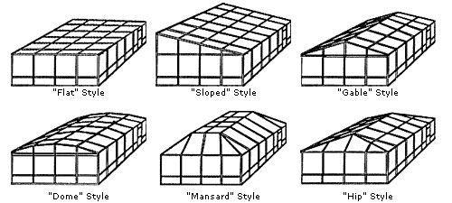
The aluminum pool enclosure system consists of the main beam overhead that span the enclosure to the aluminum columns. The lateral system consists of lateral struts and tension cables located on each side of the screened structure. The gravity and lateral resisting members also consisted of connection plates and gussets to connect the members, which were fastened by threaded or screw type fasteners. The connection to the concrete consisted of a mechanically or screw type fastener and were present at the columns as well as along the base strut.
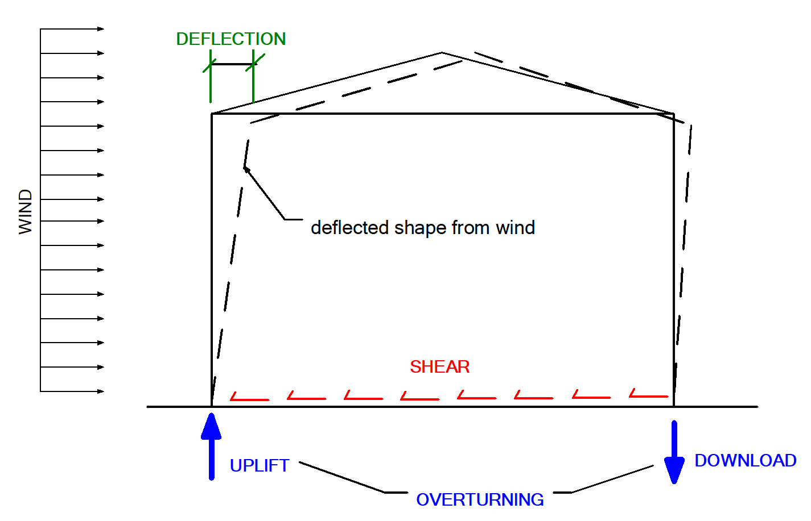
Pool enclosures consists of lateral and gravity force resisting members and systems. While gravity is taken up by the members and screens the lateral system consists of struts, cable ties, diagonal struts, and more or even using a combination of both. While the enclosure is covered in a screen, and that screen is semi-permeable, the screen will distribute wind load to the lateral force resisting members.
As static wind pressures, which are experienced by straight line winds on a structure, are distributed to the lateral force resisting members of the pool enclosure the structure will try to shift at the top (deflection), shift at the base (shear), and “over-turn” (Uplift) from the connections between members and to the foundation below. This is when you see damage to the structural lateral and gravity force resisting members in the form of twisted members, deflected columns and supports, fastener damage and shear at the base, fastener shear and twisting at connections, over stressed cable tension ties, etc.

Weather History
The information contained in this section of our report, is a representative analysis of the weather around the date of loss. Our firm has researched available weather data sources for the surrounding area to identify the weather conditions that took place near the property.
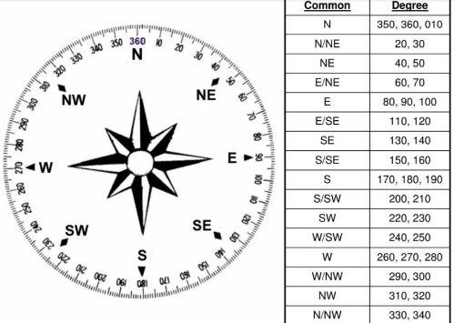

Weather Stations - NOAA – National Centers for Environmental Information (NCEI)
Table 1 covers the weather events from January 8th, 2022, through January 12th, 2022. The facts gathered aided in substantiating the wind direction, maximum wind speed and precipitation. The data was derived from Fort Pierce St. Lucie County and XXXXX International Airport’s weather stations (KFPR and XXXX). The wind direction, max wind speeds, max gust speeds, and precipitation were recorded in Table 1 and 2.
Table 1 - Weather Data from National Weather Service NOAA
Date | Location | Precipitation | Peak Speed | Peak Direction | Sustained Speed | Sustained Direction
01/08/2022 | KFPR | 0.00 | 23 | 90 | 18 | 100
01/09/2022 | KFPR | T | 30 | 110 | 24 | 110
01/10/2022 | KFPR | 0.60 | 23 | 320 | 17 | 320
01/11/2022 | KFPR | 0.00 | 25 | 400 | 16 | 60
01/12/2022 | KFPR | 0.27 | 23 | 320 | 17 | 320

Table 2 – Weather Data from National Weather Service NOAA
Date | Location | Precipitation | Peak Speed | Peak Direction | Sustained Speed | Sustained Direction
07/20/2021 | KFPR | 0.69 | 46 | 220 | 30 | 220
08/25/2021 | KFPR | 0.27 | 40 | 100 | 31 | 100
12/21/2021 | KFPR | 0.08 | 42 | 220 | 31 | 220
03/12/2022 | KFPR | 0.26 | 58 | 280 | 43 | 280
04/07/2022 | KFPR | 0.77 | 82 | 280 | 41 | 290

*See Appendix C for further information

Storm Events Database - NOAA – National Centers for Environmental Information (NCEI)
Event | [TYPE] - [DATE] - [MAGNITUDE??]
County/Area
Episode Narrative
Event Narrative
*See Appendix C for further information
Event | [TYPE] - [DATE] - [MAGNITUDE??]
County/Area
Episode Narrative
Event Narrative
*See Appendix C for further information

Radar Data- NOAA – National Centers for Environmental Information (NCEI)
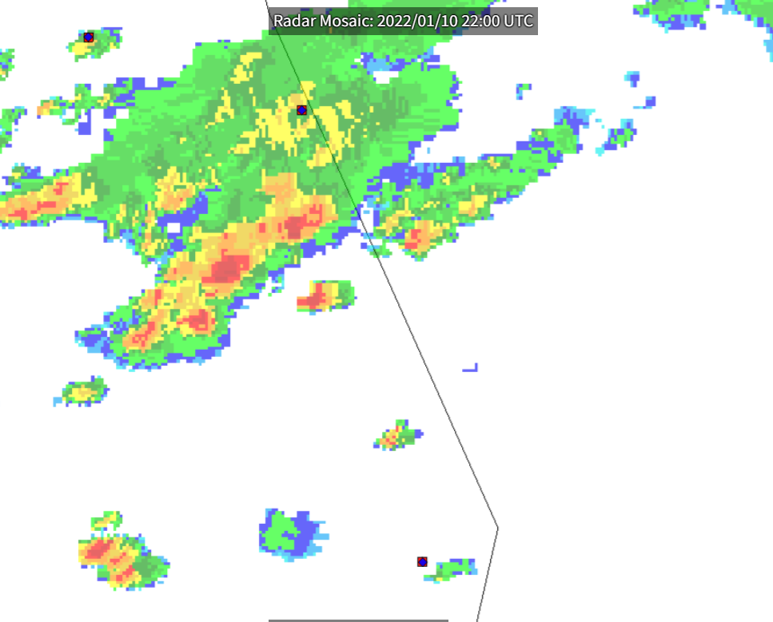 | 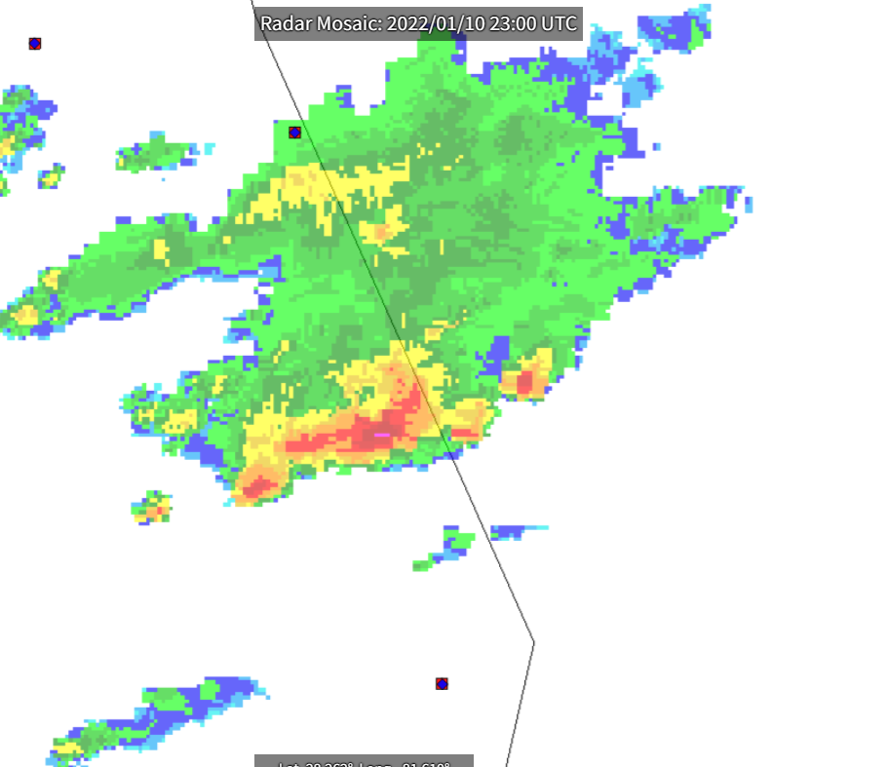
Storm Event: 01/10/2022 22:00 UTC | Storm Event: 01/10/2022 23:00 UTC

Hail Report Data- HailPoint
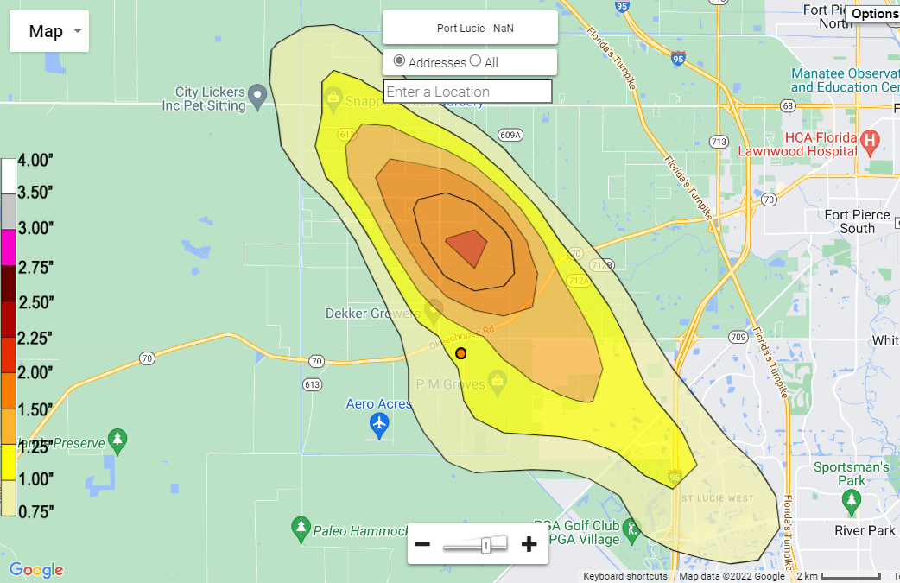
Hail Map for January 10, 2022 - Max Hail Size in area: 2.25 Inches

Weather Reports – Third Party Service Weather Records and Verification

Benchmark
The property we inspected was in Port St. Lucie, FL, and in Appendix C we have included a historical table that includes dates where there were significant wind gusts and Hail reported at and around the property. The Benchmark report uses a proprietary algorithm to determine the significant wind gusts at a range from the property requested. This data is recorded to back from 2009.

[Shingle] Resources [verify necessary sources added per case type]
The data resources reviewed in relationship to the opinions included in this report were obtained from the following reference materials:

- National Weather Service (NOAA)
- Gypsum Association, Assessing Water Damage to Gypsum Board (GA-231-06)
- ASCE7, Minimum Design Loads for Buildings and Other Structures
- Florida Building Code – Existing Building
- Google Earth Pro- Historical Satellite Images
- St. Lucie County Property Appraiser
- IBEC-International Institute of Building Enclosure Consultants https://iibec.org/misconceptions-wind-damage-asphalt-composition-shingles/
- NOAA Storm Event Database
- InterNACHI Gallery Hail Damage to Asphalt Shingles - Hail Damage to Asphalt Shingles - Inspection Gallery - InterNACHI®
- Hail Maps – Hail Maps & Hail Reports for the Hail Damage Restoration Industry. Interactive Hail Maps of the Hail Trace and Hail Swaths of Every Hail Storm in the US. (hailpoint.com)

[TILE] Resources [verify necessary sources added per case type]
The data resources reviewed in relationship to the opinions included in this report were obtained from the following reference materials:

- NOAA – National Weather Service
- American National Standard for Evaluating the Simulated Wind Uplift Resistance of Roof Assemblies Using Static Positive and/or Negative Differential Pressures, ANSI/FM Approvals 4474, March 2004
- Gypsum Association, Assessing Water Damage to Gypsum Board (GA-231-06)
- Standard and Reference Guide for Professional Mold Remediation, IICRC S520.
- Figure 1: Wind Effects on Roof, https://www.nrc-cnrc.gc.ca/ctu-sc/en/ctu_sc_n55/
- ASCE7, Minimum Design Loads for Buildings and Other Structures
- Florida Building Code – Existing Building
- https://tileroofing.org/wp-content/uploads/2014/02/99-002-chipped-tile.pdf
- https://tileroofing.org/wp-content/uploads/TRI-Obsolete-Concrete-Roof-Tile-rev10092017.pdf
- Miami-Dade County Property Appraiser
- Google Earth Pro Historical Satellite images
- InterNACHI Gallery Hail Damage to Asphalt Shingles - Hail Damage to Asphalt Shingles - Inspection Gallery - InterNACHI®
- Hail Maps – Hail Maps & Hail Reports for the Hail Damage Restoration Industry. Interactive Hail Maps of the Hail Trace and Hail Swaths of Every Hail Storm in the US. (hailpoint.com)

HIGH WIND OPINIONS

[SHINGLE list] Opinions and Recommendations
It is in Synergyn’s professional opinion within a reasonable degree of engineering certainty that the roof has sustained damages due to the storm event brought on by hurricane Irma. The following opinion and recommendations are held to the same reasonable degree of engineering certainty. The wind pressure mixed with the precipitation observed was able to create hurricane event roof and exterior openings that allowed water to penetrate the interior of the home, wind borne debris, and damage to the property addressed.
Dynamic forces brought to by the hurricane force winds caused damages to house roof/exterior and created storm event openings where water entered the building,

Repairs
Repairs can be were witnessed at the [LOCATION] located above [LOCATION] (Photos ##-##). Repairs to the interior were also witnessed in the form of painted ceiling and patched gypsum at the [LOCATION] (Photos ##-##).

Water Staining/Damage: Attic/Interior
Repairs can be were witnessed at the [LOCATION] located above [LOCATION] (Photos ##-##). Repairs to the interior were also witnessed in the form of painted ceiling and patched gypsum at the [LOCATION] (Photos ##-##).

Exterior Damages
Repairs can be were witnessed at the [LOCATION] located above [LOCATION] (Photos ##-##). Repairs to the interior were also witnessed in the form of painted ceiling and patched gypsum at the [LOCATION] (Photos ##-##).

It is our recommendation that the above-mentioned items listed in the “Observations and Consulting” section be repaired and/or replaced to prevent further and future damage.
Large and numerous sections of the roof were damaged, and that repairs are not feasible

Asphalt Shingle Roof Damages
Repairs can be were witnessed at the [LOCATION] located above [LOCATION] (Photos ##-##). Repairs to the interior were also witnessed in the form of painted ceiling and patched gypsum at the [LOCATION] (Photos ##-##).

Asphalt Shingle Roof Damages: High Pressure Zones
Damages witnessed such as unadhered, torn, creased, and missing shingle were located along edges, eaves, ridges, hips, and corners, which are areas that experience higher pressures and wind force. (Photos ##-##).

Asphalt Shingle Roof Damages: Hail Impact Damages
Damages witnessed such as unadhered, torn, creased, and missing shingle were located along edges, eaves, ridges, hips, and corners, which are areas that experience higher pressures and wind force. (Photos ##-##).
In order to comply with Florida Building Code, it is required to have all singles replaced, “706.1.1 Not more than 25 percent of the total roof area or roof section of any existing building or structure shall be repaired, replaced or recovered in any 12-month period unless the entire roofing system or roof section conforms to requirements of this code.” Given the visual inspection of the roof it is evident that more than 25% of the roof is damaged and that the extent of the damages across multiple faces of the roof, damages witnessed from the eaves to the ridges, and the requirement for replacing the damaged membranes, any attempt to “patch” damaged areas would further exacerbate the roof’s already degenerating condition. Therefore, the roofing system must be removed and replaced. These repairs will require a permits and inspection. Furthermore, during a replacement, a roofing system shall not be applied over an existing roof deck without proper fastening and condition per FBC Building 1521.5 and will need to be followed in the process.

FBC Building 1521.5 “A roofing system shall not be applied over an existing roof or over an existing roof deck where the roof sheathing has not been fastened in compliance with this code or where the roof sheathing will not permit effective fastening or where sheathing is water soaked or deteriorated so that effective attachment is not possible. All areas of deteriorated sheathing shall be removed and replaced.”
Based on the extent of the damages we have witnessed during our investigation; it is evident that the only storm that could have caused this much damage would be Hurricane Irma. The Benchmark report in Appendix C shows substantial wind gusts over a 10-year period at location, within a 1-mile, and within a 5-mile radius of the property. Furthermore, the direction of wind is essential in considering the timeframe of the damages, and given the damages in the windward direction of the residence and the high-pressure zones, further exemplifies that Hurricane Irma to be the DOL. There are no named storms or unnamed storms within a 10-year period that matches the strength and capability of destruction as Hurricane Irma. Attached in this report in Appendix C, are approximate wind speeds from pre – and post Irma storms within a 10-year period.

Damage to the roof system, created openings in which rainwater was able to enter the home, causing damage to the interior of the building. Water staining in the attic is present which was caused by the storm event openings that lead to water leaking from the roof surface into the interior. Given our findings we recommend a full roof replacement and the replacement and refinishing of all interior damages highlighted in “Observations and Consulting” and “Opinions and Recommendations”. Given the amount of water damage witnessed, we also recommend an airborne mold test to ensure the safe conditions of the home.

[SHINGLE] Opinions and Recommendations
It is in Synergyn’s professional opinion within a reasonable degree of engineering certainty that the roof has sustained damages due to the storm event brought on by hurricane Irma. The following opinion and recommendations are held to the same reasonable degree of engineering certainty. The wind pressure mixed with the precipitation observed was able to create hurricane event roof and exterior openings that allowed water to penetrate the interior of the home, wind borne debris, and damage to the property addressed.
Dynamic forces brought to by the hurricane force winds caused damages to house roof/exterior and created storm event openings where water entered the building, staining the ceiling. The water staining and damage to the master bedroom (Photos 6 - 8) can be directly corelated to the water staining to the sheathing in the attic (Photo 10, 11) directly above. The bathroom was painted and repaired during our inspection, but the attic space above shows damage (Photos 9, 12) which are sings of a damage due to the hurricane wind event. It is our recommendation that the above-mentioned items listed in the “Observations and Consulting” section be repaired and/or replaced to prevent further and future damage.
Large and numerous sections of the roof were damaged, and that repairs are not feasible. Many of the damages to the roof shingles appeared in series and showed signs un-adhered shingles, torn, missing and creased shingles, both consistent with wind related damages (Photos XX - XX). These damages correlate to hurricane Irma’s wind direction, wind speed, and duration. In order to comply with Florida Building Code, it is required to have all roof shingles replaced, “706.1.1 Not more than 25 percent of the total roof area or roof section of any existing building or structure shall be repaired, replaced or recovered in any 12-month period unless the entire roofing system or roof section conforms to requirements of this code.” Given the visual inspection of the roof it is evident that more than 25% of the roof is damaged and that the extent of the damages across multiple faces of the roof, damages witnessed from the eaves to the ridges, and the requirement for replacing the damaged membranes, any attempt to “patch” damaged areas would further exacerbate the roof’s already degenerating condition. Therefore, the roofing system must be removed and replaced. These repairs will require a permits and inspection. Furthermore, during a replacement, a roofing system shall not be applied over an existing roof deck without proper fastening and condition per FBC Building 1521.5 and will need to be followed in the process.

FBC Building 1521.5 “A roofing system shall not be applied over an existing roof or over an existing roof deck where the roof sheathing has not been fastened in compliance with this code or where the roof sheathing will not permit effective fastening or where sheathing is water soaked or deteriorated so that effective attachment is not possible. All areas of deteriorated sheathing shall be removed and replaced.”
Based on the extent of the damages we have witnessed during our investigation; it is evident that the only storm that could have caused this much damage would be Hurricane Irma. The Benchmark report in Appendix C shows substantial wind gusts over a 10-year period at location, within a 1-mile, and within a 5-mile radius of the property. Furthermore, the direction of wind is essential in considering the timeframe of the damages, and given the damages in the windward direction of the residence and the high-pressure zones, further exemplifies that Hurricane Irma to be the DOL. There are no named storms or unnamed storms within a 10-year period that matches the strength and capability of destruction as Hurricane Irma. Attached in this report in Appendix C, are approximate wind speeds from pre – and post Irma storms within a 10-year period.

Damage to the roof system, created openings in which rainwater was able to enter the home, causing damage to the interior of the building. Water staining in the attic is present which was caused by the storm event openings that lead to water leaking from the roof surface into the interior. Given our findings we recommend a full roof replacement and the replacement and refinishing of all interior damages highlighted in “Observations and Consulting” and “Opinions and Recommendations”. Given the amount of water damage witnessed, we also recommend an airborne mold test to ensure the safe conditions of the home.

[TILE] Opinions and Recommendations
It is in Synergyn’s professional opinion within a reasonable degree of engineering certainty that the roof has sustained damages due to the storm event brought on by hurricane Irma. The following opinion and recommendations are held to the same reasonable degree of engineering certainty.
The wind pressure mixed with the precipitation observed was able to create hurricane event roof openings that allowed water to penetrate the interior of the home. The water staining and damage found at the entry (Photos 2-4) can be directly correlated with the water staining to the sheathing and trusses found in the attic area directly above (Photo 13). Similarly, the water damage to the garage ceiling (Photo 6) appears directly below water staining to the attic sheathing and trusses directly above (Photo 14). Although not visible in the attic, Water staining can be seen on the master bathroom ceiling (Photos 7,8). Moisture meter tests were taken during this inspection at the entry (Photo 5) and fascia boards (Photo 12) which revealed higher levels of moisture the closer the tested areas. Excessive roof tile chattering cause by high winds has caused the displacement (slipping, shifting, uplifting) of series of numerous tiles along the roof. Dynamic forces brought to by the hurricane force winds caused damages to the house roof, and evidence of water can be seen inside the attic.

Large and numerous sections of the roof were damaged, and we recommend a full replacement of the roof. Roof damages consist of broken, uplifted, shifted and loose tiles. Many of the tiles were damaged in a series (Photos 16,18,25,29-31) and show damage to the mortar bond of the hip and ridge caps where the dynamic pressures of hurricane Irma were able to “lift” the field tiles (Photos 19-21,27-29,32), both of which are consistent with wind related damages due to hurricane Irma. Additionally, damages were found along the edges, corners, and hips (Photos 18-21,27-29,31,32). These areas are known as high pressure zones and are more susceptible to high wind pressures, and correlate to the wind speed, wind direction, and wind duration of the storm event brought on by hurricane Irma. It should also be noted that the make of the existing tiles is “” which is discontinued, according to the tile roofing institute. The list of discontinued tiles is current per the revision on October 05, 2017. In order to comply with Florida Building Code, it is required to have all roof tiles replaced, “706.1.1 Not more than 25 percent of the total roof area or roof section of any existing building or structure shall be repaired, replaced or recovered in any 12-month period unless the entire roofing system or roof section conforms to requirements of this code.” Given the visual inspection of the roof it is evident that more than 25% of the roof is damaged and that the extent of the damages across multiple faces of the roof, damages witnessed from the eaves to the ridges, the current discontinued tile that doesn’t not have a proper interlocking substitute, and the requirement for replacing the damaged membranes, any attempt to “patch” damaged areas would further exacerbate the roof’s already degenerating condition. Therefore, the roofing system must be removed and replaced. These repairs will require a permits and inspection. Furthermore, during a replacement, a roofing system shall not be applied over an existing roof deck without proper fastening and condition per FBC Building 1521.5 and will need to be followed in the process.

FBC Building 1521.5 “A roofing system shall not be applied over an existing roof or over an existing roof deck where the roof sheathing has not been fastened in compliance with this code or where the roof sheathing will not permit effective fastening or where sheathing is water soaked or deteriorated so that effective attachment is not possible. All areas of deteriorated sheathing shall be removed and replaced.”
Based on the extent of the damages we have witnessed during our investigation; it is evident that the only storm that could have caused this much damage would be Hurricane Irma. The Benchmark report in Appendix C shows substantial wind gusts over a 10-year period at location, within a 1-mile, and within a 5-mile radius of the property. Furthermore, the direction of wind is essential in considering the timeframe of the damages, and given the damages in the windward direction of the residence and the high-pressure zones, further exemplifies that Hurricane Irma to be the DOL. There are no named storms or unnamed storms within a 10-year period that matches the strength and capability of destruction as Hurricane Irma. Attached in this report in Appendix C, are approximate wind speeds from pre – and post Irma storms within a 10-year period.

Damage to the roof system created openings in which rainwater was able to enter the home, causing damage to the interior of the building. Water staining in the attic is present which was caused by the storm event openings that lead to water leaking from the roof surface into the interior. Given our findings we recommend a full roof replacement and the replacement and refinishing of all interior damages highlighted in “Observations” and “Opinions and Recommendations”. Given the amount of water damage witnessed, we also recommend an airborne mold test to ensure the safe conditions of the home.

[Flat WIP] Opinions and Recommendations
It is in Synergyn’s professional opinion within a reasonable degree of engineering certainty that the roof has sustained damages due to the storm event brought on by hurricane Irma. The following opinion and recommendations are held to the same reasonable degree of engineering certainty.
Dynamic forces brought by hurricane Irma winds caused damages to house roof/exterior and created storm event openings where water entered the building. The wind pressure mixed with the precipitation observed during hurricane Irma was able to damage the roof of the home. Water damages and staining can be seen on the northeast studio ceiling (Photos 2-5) and while the attic space was not accessible, the wind damage at the roof due to the induced stress and debris was able to damage the membrane (Photos 17,18,22), creating a storm event roof opening. Upon further review the roof substrate below the membrane in the northeast corner (over the efficiency) and the north section of the roof (Over the living room) was deteriorated by feeling the area topically. This is due to the water intrusion from the storm event opening from hurricane Irma.

The damages witnessed to the roof were located throughout multiple sections of the roof and were concentrated along the north side, and we recommend a full replacement of the roof due to hurricane Irma. The damages witnessed coincide with the windward direction as well as the statement from the homeowner that there was debris on the northeast corner of the roof, which are all from Hurricane Irma and the dynamic wind pressures experienced from the hurricane. Furthermore, the roof was re-roofed in 2016, roughly 1 year prior to the date of loss, which indicates that through the roof permit that the roof was done by a licensed contractor and does not indicate that there would be any existing underlying condition during replacement. Due the damages witnessed, to prevent further/future damage the complete roof should be replaced. Furthermore, during a replacement, a roofing system shall not be applied over an existing roof deck without proper fastening and condition per FBC Building 1521.5 and will need to be followed in the process.

FBC Building 1521.5 “A roofing system shall not be applied over an existing roof or over an existing roof deck where the roof sheathing has not been fastened in compliance with this code or where the roof sheathing will not permit effective fastening or where sheathing is water soaked or deteriorated so that effective attachment is not possible. All areas of deteriorated sheathing shall be removed and replaced.”
Based on the extent of the damages we have witnessed during our investigation; it is evident that the only storm that could have caused this much damage would be Hurricane Irma. The Benchmark report in Appendix C shows substantial wind gusts over a 10-year period at location, within a 1-mile, and within a 5-mile radius of the property. Furthermore, the direction of wind is essential in considering the timeframe of the damages, and given the damages in the windward direction of the residence and the high-pressure zones, further exemplifies that Hurricane Irma to be the DOL. There are no named storms or unnamed storms within a 10-year period that matches the strength and capability of destruction as Hurricane Irma. Attached in this report in Appendix C, are approximate wind speeds from pre – and post Irma storms within a 10-year period.

Damage to the roof system created openings in which rainwater was able to enter the home, causing damage to the interior of the building. Given our findings we recommend a full roof replacement and the replacement and refinishing of all interior damages highlighted in “Observations” and “Opinions and Recommendations”. Given the amount of water damage witnessed, we also recommend an airborne mold test to ensure the safe conditions of the home.

LOW WIND OPINIONS

[SHINGLE] Opinions and Recommendations
It is in Synergyn’s professional opinion within a reasonable degree of engineering certainty that the roof has sustained damages due to the wind event brought on by eta. The following opinion and recommendations are held to the same reasonable degree of engineering certainty. The wind pressure mixed with the precipitation observed was able to create wind event roof and exterior openings that allowed water to penetrate the interior of the home and damage to the property addressed.
The wind pressure mixed with the precipitation observed was able to create wind event roof openings that allowed water to penetrate the interior of the home. The water staining to the hallway ceiling (Photos 2,3) and the dining room ceiling (Photo 4) can be correlated with the wind damage on the roof near and at the ridge (Photos 17,19,20,22-30). Dynamic forces brought to by Tropical Storm ETA winds, the wind direction, and pressures experienced where able to damage the roof at the ridge where water was able to enter the home causing damage to the mentioned interior. Given our on-site review and extent of the damages witnessed, the damaged materials should be repaired/replaced in order to prevent further damage.

The permit search for the residence shows that the roof was replaced in 2002. The Tropical Storm ETA damage witnessed consisted of unadhered and damaged shingles near the ridge over the dining room and hallway (Photos 17,19,20,22-30). Furthermore, the roof has also experienced wind damage for tropical storm ETA in the form of un-adhered, creased, torn, and missing shingle at the rakes, ridges, and the flat roof to shingle roof transition. These locations are in pressure zones, by design, that experience a greater wind force. These areas experienced the dynamic wind forces from Tropical Storm ETA, damaging the roof, and lead to water intrusion into the interior. Given the extent of the damages, the age of the shingles, and the requirement for replacing the damaged membranes, any attempt to “patch” damaged areas would further exacerbate the roof’s already degenerating condition. Therefore, the roofing system must be removed and replaced. These repairs will require a permits and inspection. Furthermore, during a replacement, a roofing system shall not be applied over an existing roof deck without proper fastening and condition per FBC Building 1521.5 and will need to be followed in the process.

FBC Building 1521.5 “A roofing system shall not be applied over an existing roof or over an existing roof deck where the roof sheathing has not been fastened in compliance with this code or where the roof sheathing will not permit effective fastening or where sheathing is water soaked or deteriorated so that effective attachment is not possible. All areas of deteriorated sheathing shall be removed and replaced.”

Damage to the roof system created openings in which rainwater was able to enter the home, causing damage to the interior of the building. Given our findings we recommend a full roof replacement and the replacement and refinishing of all interior damages highlighted in “Onsite Observations” and “Opinions and Recommendations”.

[TILE] Opinions and Recommendations
It is in Synergyn’s professional opinion within a reasonable degree of engineering certainty that the roof has sustained damages due to the storm event brought on by Tropical Storm Eta. The following opinion and recommendations are held to the same reasonable degree of engineering certainty.
The wind pressure mixed with the precipitation observed was able to create wind event roof openings that allowed water to penetrate the interior of the home. The water staining to the living room ceiling (Photo 2) can be correlated with the water staining in the attic area at the low/flat roof to wall transition at the southside of the residence (Photos 9,10). Similarly, the water staining to the northwest bedroom ceiling (Photos 3,4) can be directly corelated to the water staining to the sheathing in the attic (Photos 15-16) above. The master bedroom water staining (Photos 5,7) is located around the roof to wall transition and wind damaged roof tile and membrane above (Photos 31,33,46). Dynamic forces brought to by Tropical Storm ETA winds caused damages to the house roof, and evidence of water can be seen inside the attic. Given our on-site review and extent of the damages witnessed, the damaged materials should be repaired/replaced in order to prevent further damage.

Previous repairs were made throughout the roof. Most of the repairs that had been made prior to Tropical Storm ETA were still in acceptable condition and therefore workmanship or installation of the repairs is not considered as a source of the damage witnessed. The Tropical Storm ETA damage witnessed consisted of the unadhered damaged tile and membrane at the ridge over the northwest bedroom (Photos 19-21), the loose tiles and damaged membrane at and around the low roof to wall transition over the master bedroom (Photos 31,33,46), and evidence of water intrusion through the low/flat roof wall transition at the south of the home over and in the living room. These locations are in pressure zones, by design, that experience a greater wind force. These areas experienced the dynamic wind forces from Tropical Storm ETA, damaging the roof, and lead to water intrusion into the interior. It should also be noted that the make of the existing tiles is “LifeTile” which is discontinued, according to the tile roofing institute. The list of discontinued tiles is current per the revision on October 05, 2017. Given the extent of the damages, the current discontinued tile that doesn’t not have a proper interlocking substitute, and the requirement for replacing the damaged membranes, any attempt to “patch” damaged areas would further exacerbate the roof’s already degenerating condition. Therefore, the roofing system must be removed and replaced. These repairs will require a permits and inspection. Furthermore, during a replacement, a roofing system shall not be applied over an existing roof deck without proper fastening and condition per FBC Building 1521.5 and will need to be followed in the process.

FBC Building 1521.5 “A roofing system shall not be applied over an existing roof or over an existing roof deck where the roof sheathing has not been fastened in compliance with this code or where the roof sheathing will not permit effective fastening or where sheathing is water soaked or deteriorated so that effective attachment is not possible. All areas of deteriorated sheathing shall be removed and replaced.”

Damage to the roof system created openings in which rainwater was able to enter the home, causing damage to the interior of the building. Water staining in the attic is present which was caused by the storm event openings that lead to water leaking from the roof surface into the interior. Given our findings we recommend a full roof replacement and the replacement and refinishing of all interior damages highlighted in “Onsite Observations” and “Opinions and Recommendations”. Given the amount of water damage witnessed, we also recommend an airborne mold test to ensure the safe conditions of the home.

[Flat WIP] Opinions and Recommendations
It is in Synergyn’s professional opinion within a reasonable degree of engineering certainty that the roof has sustained damages due to the storm event brought on by hurricane Irma. The following opinion and recommendations are held to the same reasonable degree of engineering certainty.
Dynamic forces brought by hurricane Irma winds caused damages to house roof/exterior and created storm event openings where water entered the building. The wind pressure mixed with the precipitation observed during hurricane Irma was able to damage the roof of the home. Water damages and staining can be seen on the northeast studio ceiling (Photos 2-5) and while the attic space was not accessible, the wind damage at the roof due to the induced stress and debris was able to damage the membrane (Photos 17,18,22), creating a storm event roof opening. Upon further review the roof substrate below the membrane in the northeast corner (over the efficiency) and the north section of the roof (Over the living room) was deteriorated by feeling the area topically. This is due to the water intrusion from the storm event opening from hurricane Irma.

The damages witnessed to the roof were located throughout multiple sections of the roof and were concentrated along the north side, and we recommend a full replacement of the roof due to hurricane Irma. The damages witnessed coincide with the windward direction as well as the statement from the homeowner that there was debris on the northeast corner of the roof, which are all from Hurricane Irma and the dynamic wind pressures experienced from the hurricane. Furthermore, the roof was re-roofed in 2016, roughly 1 year prior to the date of loss, which indicates that through the roof permit that the roof was done by a licensed contractor and does not indicate that there would be any existing underlying condition during replacement. Due the damages witnessed, to prevent further/future damage the complete roof should be replaced. Furthermore, during a replacement, a roofing system shall not be applied over an existing roof deck without proper fastening and condition per FBC Building 1521.5 and will need to be followed in the process.

FBC Building 1521.5 “A roofing system shall not be applied over an existing roof or over an existing roof deck where the roof sheathing has not been fastened in compliance with this code or where the roof sheathing will not permit effective fastening or where sheathing is water soaked or deteriorated so that effective attachment is not possible. All areas of deteriorated sheathing shall be removed and replaced.”
Based on the extent of the damages we have witnessed during our investigation; it is evident that the only storm that could have caused this much damage would be the wind event. The Benchmark report in Appendix C shows substantial wind gusts over a 10-year period at location, within a 1-mile, 3-mile, and 10-mile radius of the property. Furthermore, the direction of wind is essential in considering the timeframe of the damages, and given the damages in the windward direction of the residence and the high-pressure zones, further exemplifies that wind event to be the DOL. There are no named storms or unnamed storms within a 10-year period that matches the strength and capability of destruction as Hurricane Irma. Attached in this report in Appendix C are approximate wind speeds from pre – and post wind event storms within a 10-year period.

Damage to the roof system created openings in which rainwater was able to enter the home, causing damage to the interior of the building. Given our findings we recommend a full roof replacement and the replacement and refinishing of all interior damages highlighted in “Observations” and “Opinions and Recommendations”. Given the amount of water damage witnessed, we also recommend an airborne mold test to ensure the safe conditions of the home.

[Devon] Signature
This report is based on relevant information known to Synergyn at the time the report is issued. Synergyn reserves the right to amend or supplement this report if additional relevant information becomes available.

Synergyn appreciates this opportunity to have assisted you with this investigation. Please contact us if you have any questions or need additional information.

Sincerely,
Synergyn

 | Date  This item has been digitally signed and sealed by Devon Hunt, P.E. on _____________  Printed copies of the document are not considered signed and sealed and the signature must be verified on any electronic copies.
Devon Hunt, P.E.
Principal Engineer
Professional Engineer FL PE: 89976

[Chris] Signature
This report is based on relevant information known to Synergyn at the time the report is issued. Synergyn reserves the right to amend or supplement this report if additional relevant information becomes available.

Synergyn appreciates this opportunity to have assisted you with this investigation. Please contact us if you have any questions or need additional information.

Sincerely,
Synergyn


Date
This item has been digitally signed and sealed by Christopher Charles Thompson, P.E. on _____________
Printed copies of the document are not considered signed and sealed and the signature must be verified on any electronic copies.

Christopher C. Thompson, P.E.
Principal Engineer
Professional Engineer FL PE: 86787

[Esteban] Signature
This report is based on relevant information known to Synergyn at the time the report is issued. Synergyn reserves the right to amend or supplement this report if additional relevant information becomes available.

Synergyn appreciates this opportunity to have assisted you with this investigation. Please contact us if you have any questions or need additional information.

Sincerely,
Synergyn

 | This item has been digitally signed and sealed by Esteban O. Rios M., P.E. on DATE.  Printed copies of the document are not considered signed and sealed and the signature must be verified on any electronic copies.
Esteban O. Rios M., P.E.
Professional Engineer FL PE: 95221

[Ahmad] Signature
This report is based on relevant information known to Synergyn at the time the report is issued. Synergyn reserves the right to amend or supplement this report if additional relevant information becomes available.

Synergyn appreciates this opportunity to have assisted you with this investigation. Please contact us if you have any questions or need additional information.

Sincerely,
Synergyn

 | 6/22/24  This item has been digitally signed and sealed by Ahmad Chehab, P.E. on _____________  Printed copies of the document are not considered signed and sealed and the signature must be verified on any electronic copies.
Ahmad Chehab, P.E.
Professional Engineer FL PE: 96851

[Glen] Signature
This report is based on relevant information known to Synergyn at the time the report is issued. Synergyn reserves the right to amend or supplement this report if additional relevant information becomes available.

Synergyn appreciates this opportunity to have assisted you with this investigation. Please contact us if you have any questions or need additional information.

Sincerely,
Synergyn
DATE
 | This item has been digitally signed and sealed by Glen Heagerty, P.E. on _____________  Printed copies of the document are not considered signed and sealed and the signature must be verified on any electronic copies.
Glen Heagerty, P.E.
Professional Engineer FL PE: 96282

APPENDIX A-#
  - Photo Documentation
[APPLY NECESSARY PHOTOGRAPHY, DELETE UNUSED TABLES. IF USING MULTILE SOURCES, Use numbering in place of “#” above]

Photographs – From Synergyn 09/30/2020
Photo 001 – |  | Photo 002 –
Photo 003 – |  | Photo 004 –
Photo 005 – |  | Photo 006 –

Photo 007 – |  | Photo 008 –
Photo 009 – |  | Photo 010 –
Photo 011 – |  | Photo 012 –

Photo 013 – |  | Photo 014 –
Photo 015 – |  | Photo 016 –
Photo 017 – |  | Photo 018 –

Photo 019 – |  | Photo 020 –
Photo 021 – |  | Photo 022 –
Photo 023 – |  | Photo 024 –

Photo 025 – |  | Photo 026 –
Photo 027 – |  | Photo 028 –
Photo 029 – |  | Photo 030 –

Photo 031 – |  | Photo 032 –
Photo 033 – |  | Photo 034 –
Photo 035 – |  | Photo 036 –

Photo 037 – |  | Photo 038 –
Photo 039 – |  | Photo 040 –
Photo 041 – |  | Photo 042 –

Photo 043 – |  | Photo 044 –
Photo 045 – |  | Photo 046 –
Photo 047 – |  | Photo 048 –

Photo 049 – |  | Photo 050 –
Photo 051 – |  | Photo 052 –
Photo 053 – |  | Photo 054 –

Photo 055 – |  | Photo 056 –
Photo 057 – |  | Photo 058 –
Photo 059 – |  | Photo 060 –

APPENDIX A-#
  - Photo Documentation
[APPLY NECESSARY PHOTOGRAPHY, DELETE UNUSED TABLES. IF USING MULTILE SOURCES, Use numbering in place of “#” above]

Photographs – From Synergyn 09/30/2020
Photo 001 – |  | Photo 002 –
Photo 003 – |  | Photo 004 –
Photo 005 – |  | Photo 006 –

Photo 007 – |  | Photo 008 –
Photo 009 – |  | Photo 010 –
Photo 011 – |  | Photo 012 –

Photo 013 – |  | Photo 014 –
Photo 015 – |  | Photo 016 –
Photo 017 – |  | Photo 018 –

Photo 019 – |  | Photo 020 –
Photo 021 – |  | Photo 022 –
Photo 023 – |  | Photo 024 –

Photo 025 – |  | Photo 026 –
Photo 027 – |  | Photo 028 –
Photo 029 – |  | Photo 030 –

APPENDIX A-#
  - Photo Documentation
[APPLY NECESSARY PHOTOGRAPHY, DELETE UNUSED TABLES. IF USING MULTILE SOURCES, Use numbering in place of “#” above]

Photographs – From Synergyn 09/30/2020
Photo 001 – |  | Photo 002 –
Photo 003 – |  | Photo 004 –
Photo 005 – |  | Photo 006 –

Photo 007 – |  | Photo 008 –
Photo 009 – |  | Photo 010 –
Photo 011 – |  | Photo 012 –

Photo 013 – |  | Photo 014 –
Photo 015 – |  | Photo 016 –
Photo 017 – |  | Photo 018 –

Photo 019 – |  | Photo 020 –
Photo 021 – |  | Photo 022 –
Photo 023 – |  | Photo 024 –

Photo 025 – |  | Photo 026 –
Photo 027 – |  | Photo 028 –
Photo 029 – |  | Photo 030 –

APPENDIX B
  - PERMIT HISTORY

{INSERT HERE AND ALIGN]
{INSERT HERE AND ALIGN]
{INSERT HERE AND ALIGN]

APPENDIX C
  - WEATHER DATA

{INSERT HERE AND ALIGN]
{INSERT HERE AND ALIGN]
{INSERT HERE AND ALIGN]

